
NATIONAL INSTITUTE OF TECHNOLOGY PUDUCHERRY
(An Institution of National Importance under MHRD, Govt. of India)
KARAIKAL – 609 609

DEPARTMENT OF COMPUTER SCIENCE AND ENGINEERING
Roll Number: | CS19B1016 | Name | BOYINA AJAY SANTHOSH
Semester: | II | Class: | B TECH 1ST YEAR
Subject Code: | CS106 | Subject Name: | DATA STRUCTURES LABORATORY

6.1 REVERSE LINKED LIST
Date:10.2.20

AIM:

To IMPLEMENT A REVERSE LINKED LIST PROGRAM BY USING C PROGRAM.

ALGORITHM:
1. Start the program.
2. create a linked list and return head.
3. declare node pointers prev,current , nextnode.
4.first prev=NULL and current and nextnode= head.
5.enter into while loop and its condition nextnode !=NULL
6. now nextnode=current ->next because we are trying to store address of previous node in the pointer ‘next’ of this node.
7. So link will be breaked therefore nextnode points to address of next node.
8.now current->next=prev since we have to form reverse linked list we have to store the address of previous node in the pointer ‘next’ of this node.
9.now prev=current since we r going to the next node.
10.now current = nextnode because now next node is our current node.
11. after coming out from while loop the value of prev is to store in the head
12.Because now last node becomes first node since we reversed a linked list so now head is equal to address of last node.
13. Now display the data present in nodes after reversing a linked list.
14. Close the program.

PROGRAM:

#include<stdio.h>
#include<stdlib.h>
struct node
{
int data;
struct node *next;
};
int count=0;
typedef struct node nd;
nd *linkedlist(nd *head,nd *newnode)
{
nd *temp;
int choice;
head=NULL;
do
{
newnode=(nd *)malloc(sizeof(nd));
printf("enter choice=1 for continuation of loop\n");
scanf("%d",&choice);
printf("enter data to insert\n");
scanf("%d",&newnode->data);
newnode->next=NULL;
if(head==NULL)
{
head=newnode;
temp=newnode;
}
else
{
temp->next=newnode;
temp=newnode;
}
}
while(choice!=0);
temp=head;
printf("BEFORE REVERSING A LINKED LIST\n");
while(temp!=NULL)
{
count++;
printf("%d is data for node %d\n",temp->data,count);
temp=temp->next;
}
printf("head points to %d\n",head);
printf("count=%d\n",count);
return head;
}
nd * reverselink(nd *head)
{
nd *pcurrent,*pnext,*prevnode,*temp;
int count1=0;
prevnode=NULL;
pnext=pcurrent=head;
printf("\n");
printf("REVERSE LINKED LIST IS:\n");
while(pnext!=NULL)
{
pnext=pcurrent->next;
pcurrent->next=prevnode;
prevnode=pcurrent;
pcurrent=pnext;
}
head=prevnode;
temp=head;
while(temp!=NULL)
{
count1++;
printf("%d is data for node %d\n",temp->data,count1);
temp=temp->next;
}
printf("head points to %d\n",head);
return head;
}
int main()
{
nd *head,*newnode;
head=linkedlist(head,newnode);
head=reverselink(head);
}

OUTPUT:

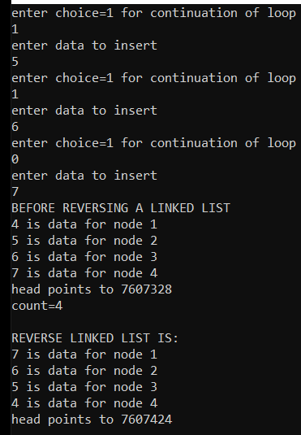

RESULT:
The program is successfully executed.

6.2 MERGING OF TWO LINKED LISTS
AIM:
To merge two linked lists through c program.

ALGORITHM:
1. Start the program.
2. create two linked lists and return their heads.
3.now go into the merge function.
4. declare node pointer ‘sorting’ it is used to create a link between two linked lists.
5. first check whose node->data is less and store the address of that node in sorting variable.
6.repeat this process until any of the linked list is empty.
7. now join the remained linked list to this new linked list through sorting variable.
8. display the data of all nodes in merged linked list and value of head in merged linked list.
9. close the program.

PROGRAM:
#include<stdio.h>
#include<stdlib.h>
struct node
{
int data;
struct node *next;
};
typedef struct node nd;
void mergelink(nd *head1,nd *head2,nd *sorting)
{
nd *p,*q,*newhead,*temp;
newhead=NULL;
p=head1;
q=head2;
int i=1;
if(p && q)
{
if(p->data <= q->data)
{
sorting=p;
p=sorting->next;
}
else
{
sorting=q;
q=sorting->next;
}
newhead=sorting;
}
while(p && q)
{
if(p->data <= q->data)
{
sorting->next=p;
sorting=p;
p=sorting->next;
}
else
{
sorting->next=q;
sorting=q;
q=sorting->next;
}
}
if(p==NULL)
{
sorting->next=q;
}
if(q==NULL)
{
sorting->next=p;
}
temp=newhead;
printf(" MERGE LINKED LIST:\n");
while(temp!=NULL)
{
printf("%d is data for node %d\n",temp->data,i);
temp=temp->next;
i++;
}
printf("%d is newhead for merged linked list\n",newhead);
}
nd *linkedlist1(nd *head1)
{
nd *newnode1,*temp;
int choice,i=1;
head1=NULL;
do
{
newnode1=(nd *)malloc(sizeof(nd));
printf("enter choice\n");
scanf("%d",&choice);
printf("insert data:\n");
scanf("%d",&newnode1->data);
newnode1->next=NULL;
if(head1==NULL)
{
head1=newnode1;
temp=newnode1;
}
else
{
temp->next=newnode1;
temp=newnode1;
}
}
while(choice);
temp=head1;
while(temp!=NULL)
{
printf("%d is data for node %d\n",temp->data,i);
temp=temp->next;
i++;
}
printf("head points to %d\n",head1);
return head1;
}
nd *linkedlist2(nd *head2)
{
nd *newnode;
nd *temp;
int choice,i=1;
head2=NULL;
do
{
newnode=(nd *)malloc(sizeof(nd));
printf("enter choice\n");
scanf("%d",&choice);
printf("enter data\n");
scanf("%d",&newnode->data);
newnode->next=NULL;
if(head2==NULL)
{
head2=newnode;
temp=newnode;
}
else
{
temp->next=newnode;
temp=newnode;
}
}
while(choice);
temp=head2;
while(temp!=NULL)
{
printf("%d is data for node %d\n",temp->data,i);
temp=temp->next;
i++;
}
printf("head of second linked list points to %d\n",head2);
return head2;
}
int main()
{
nd *k;
nd *l;
nd *head1,*head2,*sorting;
sorting=NULL;
k=linkedlist1(head1);
l=linkedlist2(head2);
mergelink(k,l,sorting);
}

OUTPUT:

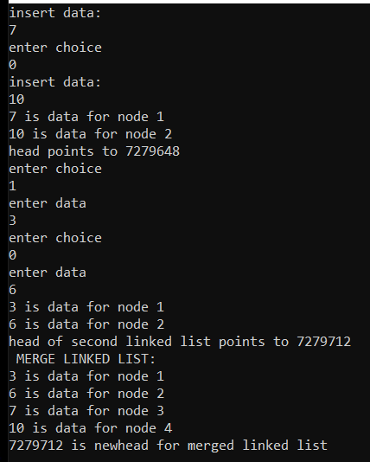

RESULT:
The program is successfully executed.

